TEAM ID: PNT2022TMID47056

PROJECT NAME: SMART FASHION RECOMMENDER SYSTEM

TEAM LEADER

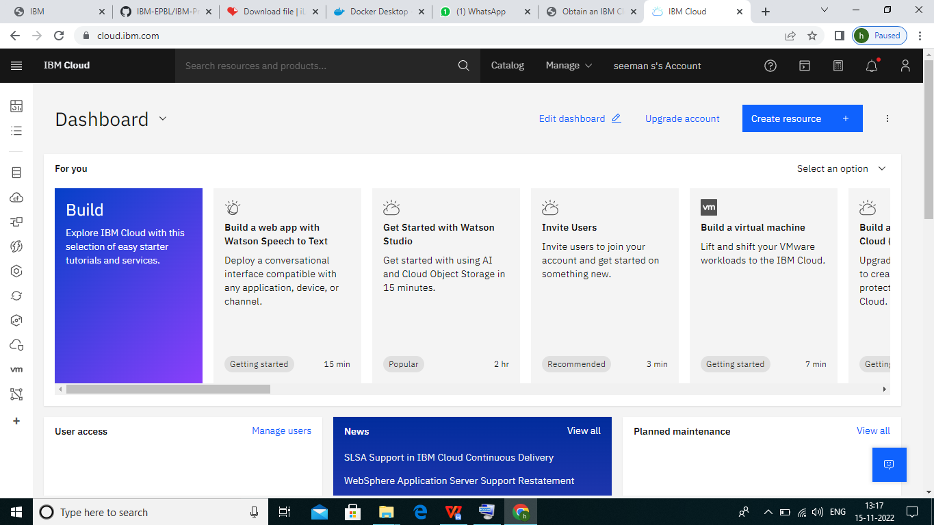

TEAM MEMBER 1

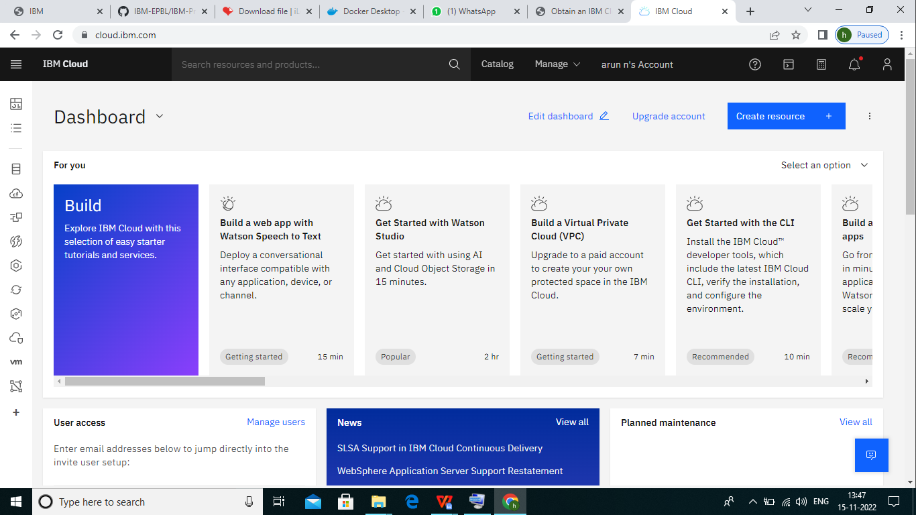

TEAM MEMBER 2

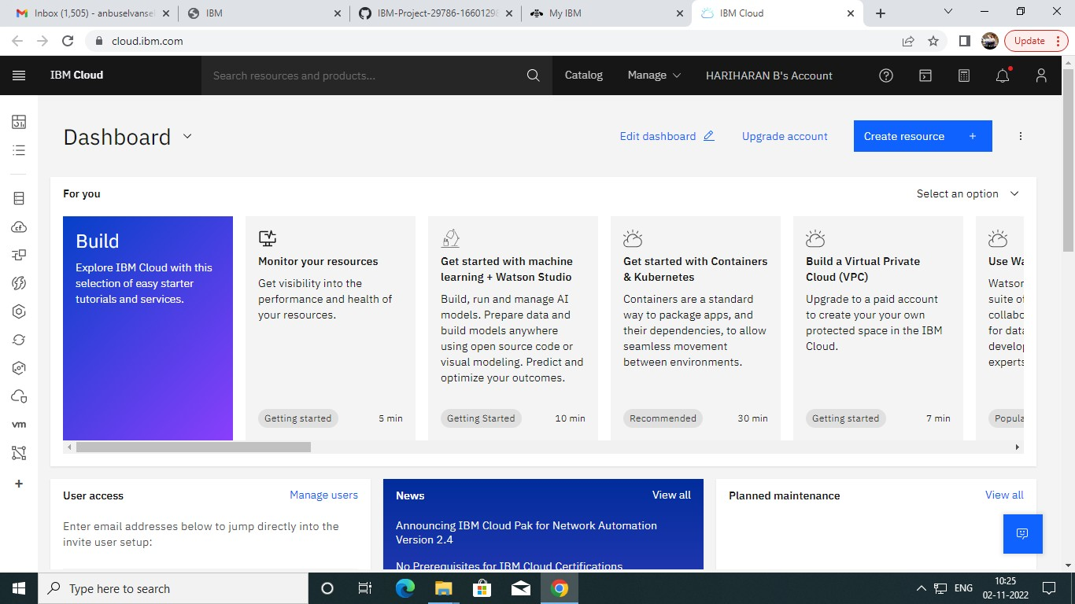

TEAM MEMBER 3

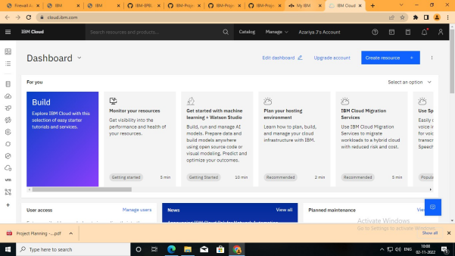

TEAM MEMBER 4

